Single use cables, for use in cardiology (with temporary pacing leads) and cardiac surgery (with heart wires), 2m length. 4m length available in some codes – please check with Customer Service.

APCC branded codes 44** = blue cable & connectors; FIAB branded codes F78** = grey cable & connectors

Stock items, 3 days delivery (max), Non stock items – please check with Customer Service

 |  | Unshrouded pins | Shrouded “touchproof” pins | REDEL (2 pin) old Pace medical Bedside | REDEL (6 pin) Biotronik Reocor S and Reocor D (off label use for ventricle only) | REDEL (2 pin) Medtronic | Osypka connector
 |  |  |  |  |  | 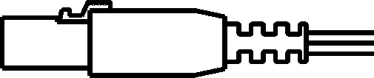 | 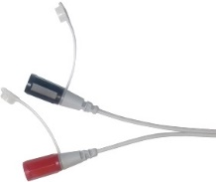
Croc clips  Used with implanted lead for threshold testing of implantable device |  | 4411 | 4421 | 4431 | On request | 4441 | On request
Screw sockets adjustable from 0.5mm to 2.0mm. Used for heart wires in cardiac surgery and unshrouded TPL pins in cardiology |  | 4412 | 4422 | 4432 | 4452 | F7818/  BMEDLC | F7818/OSYLC

 |  | Unshrouded pins | Shrouded “touchproof” pins | REDEL (2 pin) old Pace medical Bedside | REDEL (6 pin) Biotronik Reocor S and Reocor D (off label use for ventricle only) | REDEL (2 pin) Medtronic | Osypka type connector
Screw sockets quad polar  Normally used for dual chamber pacing with heart wires in cardiac surgery |  |  |  |  | 4452Q
Screw sockets with thumb wheel, adjustable from 0 to 2mm so can be used with heart wires in cardiac surgery and unshrouded TPL pins in cardiology |  | 4413 | 4423 |  | F7819/BIO | F7819/MED | F7819/OSY
Push in sockets for 2mm shrouded and unshrouded TPL pins used in cardiology |  | 4414 | 4424 |  | F7817/BIOLC | F7817/MEDLC | F7817/OSYLC

